Maidenhead Boys and Girls Football Club
Emergency Action Plan

Club Name: | Maidenhead Boys and Girls Football Club
Address: | Altwood School  Altwood Road  Maidenhead  Berkshire  SL6 4PU
First Aider Information: | All Managers and Coaches hold an FA Emergency First Aid Certificate and will be able to assist with a medical emergency. Please locate the nearest Coach or Manager should you require assistance.
Defibrillator: | Defibrillator located on the Scout Hut wall (see map below)
Stretcher: | N/A
First Aid Room: | N/A
Access for Ambulance: | Turn into the school through the entrance to the right-hand side of the main school buildings.  Follow the road straight on past the netball courts and the pitches are directly in front of you.
Nearest A&E Hospital:  Distance: 12 miles | Wexham Park Hospital, Slough, SL2 4HL.

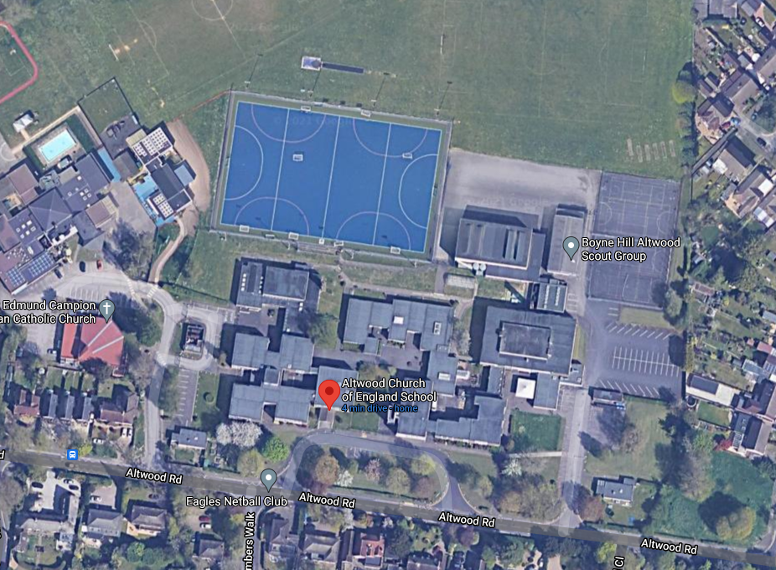
Toilets
Defibrillator
Pitches

