
Maidenhead
Boys and Girls FC
2025 Tournament Invitation

Dear Football Club

We invite your team/club to enter our annual Tournament to be played on Saturday 5th and Sunday 6th July 2025 at Braywick Sports Ground, Braywick Road, Maidenhead, Berkshire. SL6 1BN.

Following the format of previous years U9s to U18s will start on a league basis followed by a quarter final knockout tournament, where the number of entries in an age group allows.

As per normal, U7s and U8s will play a round robin friendly event at 5-aside and all participants in these age groups will receive an award.

The players in the teams who finish winners and runners-up of each competition from the U9 age group through to the U18 age group inclusive will each receive individual trophies.

Each team from U7s to U8s will consist of five players and up to 2 substitutes.
Each team from U9s to U18s will consist of six players and up to 2 substitutes.

The current 2024-2025 season age groups apply and therefore players in each age group must have been below that age as of midnight on 31st August 2024.
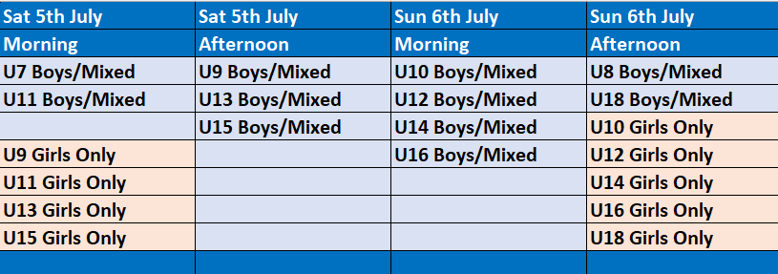
Please note that Days and Timings are subject to change.

Please note the following Rules:

There is a cap of a maximum of 3 teams allowed at any 1 age group from the same external club. Multiple team entries across a variety of age groups are welcomed though.

In addition, NO players are allowed in our Tournament who have played for any Junior Premier League team at any point in the 2024-2025 season.

Start times and further details of all arrangements, including car parking, will follow by email and be available on our website closer to the event. As in previous years there will be some side entertainment available along with the hot food stalls, ice creams and refreshments.

The early bird entry fee is £50.00 per team and is payable either by cheque made payable to Maidenhead Boys & Girls FC or by BACS to our club bank account: Sort Code 20-78-61 Account Number 3014 3340. The address to send postal applications to is:
Maidenhead Tournament c/o 1 Altwood Road, Maidenhead SL6 4PB.

Team entries after 15th May 2025 will cost £55 per team. The closing date for applications is 7th June 2025, however places will be sold on a first come, first served basis, so we encourage you to book early.

Please either complete the form below or email this information to us on the tournament email address: tournament@maidenheadbgfc.co.uk

Club Name
County FA
Club/Team FA Affiliated?
Girls Team or Boys/Mixed
2024-2025 Age Group(s)
Number of Teams (max 3 in any 1 age group from same external club)
Team Name(s)
2024-2025 League
Division Name or Number (e.g. Div 3 of 6)
ID Card System (e.g. FA Whole Game System etc)
Manager Name(s)
Mobile Number(s)
Email Address(es)
Remittance Amount
Method of Payment
Payment Reference used
Date of Payment

Acknowledgement will be sent via email so please ensure that you include an email address.

The 2025 Tournament Rules are available on our Club Website www.maidenheadbgfc.co.uk.

Yours faithfully

Sarah Shea
Tournament Secretary
Tournament@maidenheadbgfc.co.uk
Tel: 07796 074 698
http://www.maidenheadbgfc.co.uk

